**Green Society Public School**

**Ratnanagar-7, Sauraha, Chitwan**

**First Terminal Examination-2082**

**Class: L.K.G Time: - 2 hrs. F.M.: 50**

**Sub: Rhymes and Conversation P.M.: 18**

**1. Answer the following questions: [22]**

a. How are you?  
b. In which class do you read?  
c. What is your school's name?  
d. What is your class teacher’s name?  
e. How old are you?  
f. What is your country name?  
g. What is your favourite colour?  
h. What is the colour of banana?  
i. What is your father's name?  
j. What is your mother’s name?  
k. How many fingers do you have in one hand?

**2. Name the following picture. [8]**

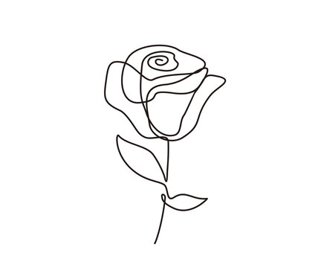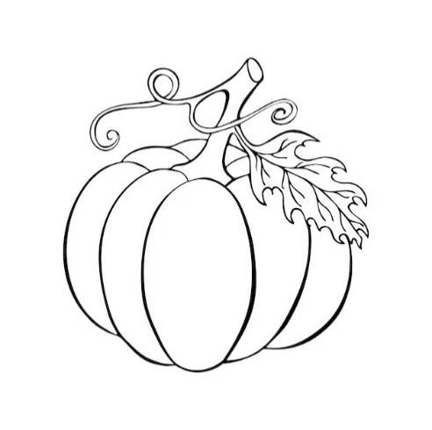



**3. Dance [5]**

**4. School uniform [5]**

**5. Rhymes [10]**

**The End**